## **Supplement Sales Prediction**

Your Client WOMart is a leading nutrition and supplement retail chain that offers a comprehensive range of products for all your wellness and fitness needs.   
  
WOMart follows a multi-channel distribution strategy with 350+ retail stores spread across 100+ cities.   
  
Effective forecasting for store sales gives essential insight into upcoming cash flow, meaning WOMart can more accurately plan the cashflow at the store level.  
  
Sales data for 18 months from 365 stores of WOMart is available along with information on Store Type, Location Type for each store, Region Code for every store, Discount provided by the store on every day, Number of Orders everyday etc.

**Procedure for to predict the store sales for each store in the test set for the next two months**

* **Step 1: Importing the Relevant Libraries**
* **Step 2: Data Inspection**
* **Step 3: Data Cleaning**
* **Step 4: Exploratory Data Analysis**
* **Step 5: Building Model**
* **How to Make a Submission?**
* **Guidelines for Final Submission**

**Step 1: Importing the Relevant Libraries**

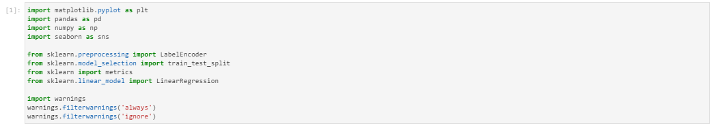

### Step 2: Data Inspection

### 

### 

**We have 188340 rows and 10 columns in Train set whereas Test set has 22265 rows and 8**

**Columns**

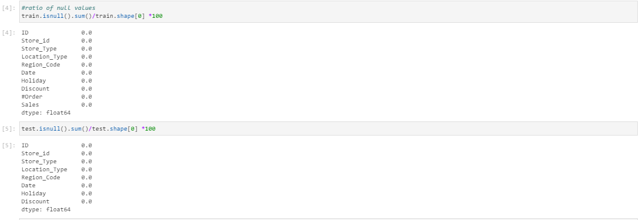

* **We don’t have missing values I both train and test dataset**

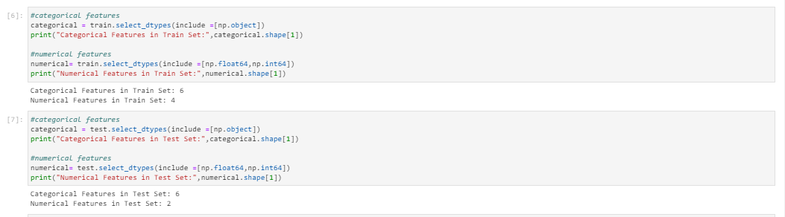

### Step 3: Data Cleaning

### Hence there is no null values and missing values this step is not required

### Step 4: Exploratory Data Analysis

### 

### 

### 

### 

### 

### 

### 

### Step 5: Building Model

* **Encoding the required columns from training and test dataset**

### ML models

### 

### 